Instruction of Black-Comet spectro radiometer
Kazunari Nozue modified on July 28, 2026
tel: 752-8086 (Maloof lab), emal:knozue@ucdavis.edu, room 2118 LSA, version 1
Purpose: To measure fluence rate (micro E).

Equipments:
Black-Coment (StellarNet, Black CXR-sR-50 (813-855-8687)) , a spectroradiometer
SpectraWiz (StellarNet)

Starting Equipments:
1. Connect Black-Comet to Toshiba laptop computer through USB cable (use right USB slot which can provide power to Black-Comet and green LED on Black-Comet turns on). If you use left USB slot, green LED on Black-Comet does not turn on.
2. Connect a detector-cable to Black-Comet. Keep the soft black cover (on the end of detector-cable) in the plastic bag.
3. Turn on Toshiba Computer and choose your account. If you do not have your account, please let Kazu know. Note: The account should be “administrator” account (not “guest”)

An outline of procedures.
1. Adjust integration time and scan numbers for averages at SCOPE mode
2. Take dark spectra at RAD mode
3. Measure sample spectra at RAD mode.
4. Store sample spectrum data (“.IRR” file)
5. Analyze the spectrum data (eg. R/FR ratio, PAR, total fluence, draw spectrum graph) (sample R scripts are available on desktop).

If you are the first time user, I recommend practicing Black Comet in your room (with fluorescent lamp on), which should give you similar spectrum shown below. If you did not see many spikes in your spectrum, something should be wrong. Follow instruction from the begging.

Detailed protocols

1. Adjust integration time and scan numbers for averages at SCOPE mode
You must be sure that you are setting the correct settings in SCOPE mode prior to each measurement. Whether the aperture is installed on the cosine receptor or not, you will need to set the integration time in SCOPE mode first. The best procedure is as follows:

1) First, after opening the software -make sure the calibration coefficients are entered properly (they should save after the first entry)
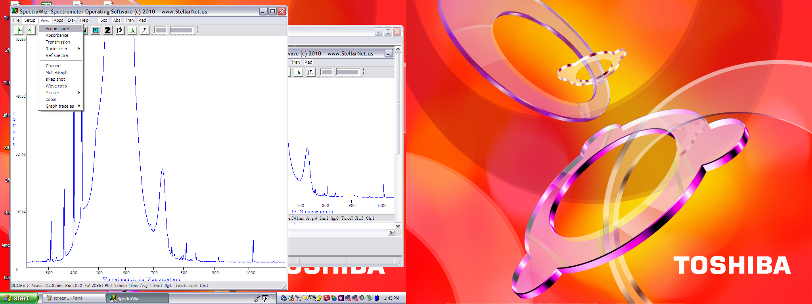
2) Start in SCOPE mode (Fig. 1) and point the receptor at your sample. This is when you’ll want to adjust your integration time, smoothing, averages, etc.

Fig.1. A magenta arrow indicates Scope mode and a green yellow indicates slide bar for adjusting integration time. Integration time (ms) is shown on the bottom of spectrum window (indicated by an yellow arrow).

3) Increase or decrease the integration so that you get the peak to the top of the screen, without being cut-off (saturating).

(Fig. 2)
2. Take dark spectra at RAD mode
4) THEN, select View > Radiometer > MicroMoles per square meter per second (Fig3).
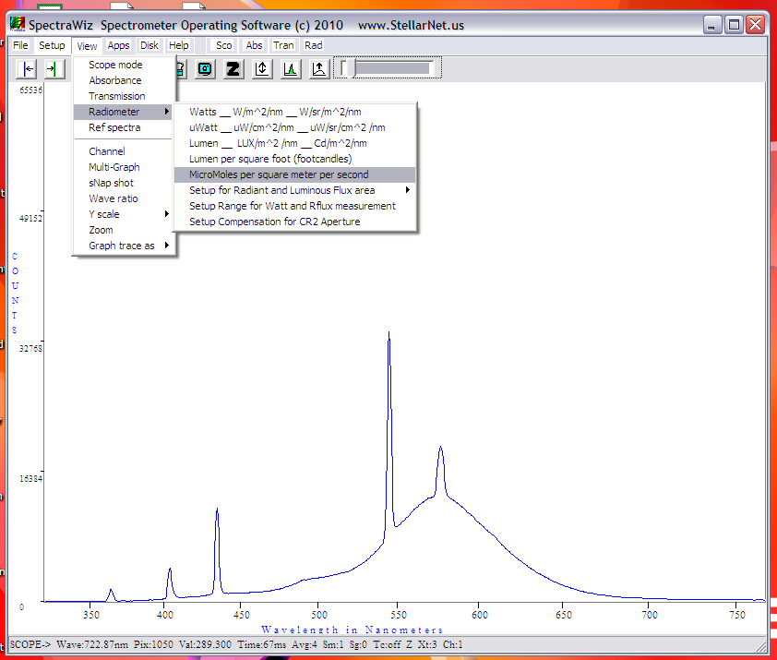 (Fig. 3)

This will change mode from SCOPE to RAD. If you have an warning message (Fig. 4), click “cancel” to keep current integration time.
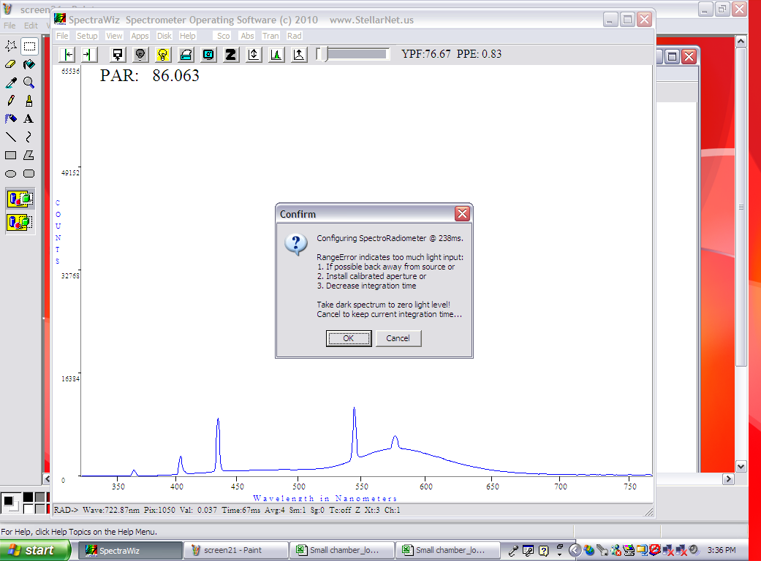 (Fig. 4)
If you OK, please start over from step2.

Unplug optical cable and place a black cap on light meter. Take a dark spectrum by clicking the black light bulb button (you will see the baseline go down to zero).(Fig. 5 and 6)
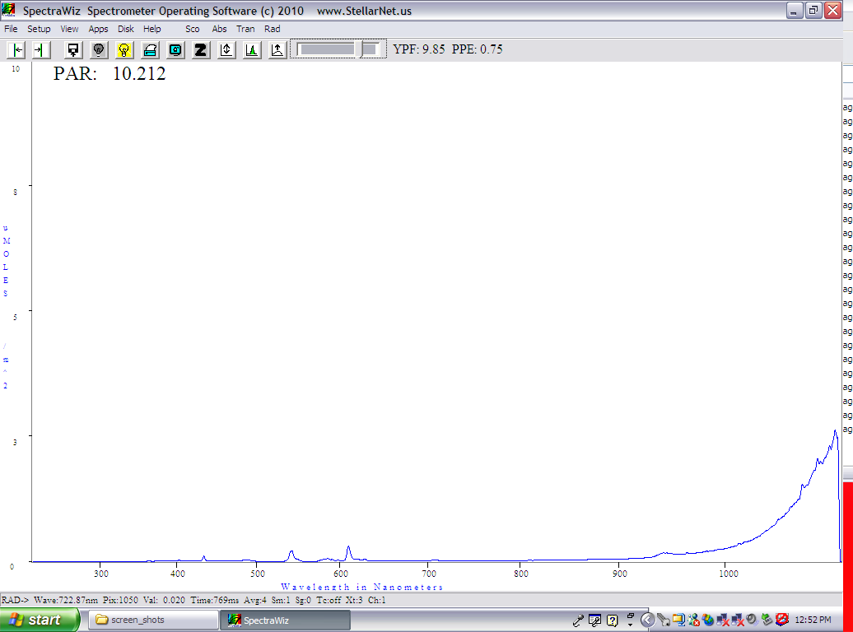 (Fig. 5, before taking a dark spectrum)
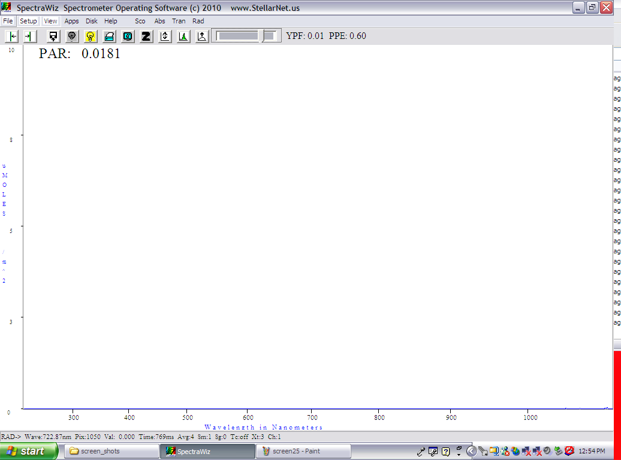 (Fig. 6, after taking a dark spectrum)
3. Measure sample spectra at RAD mode.
5) Unplug a black cap on light meter and connect an optical fiber to begin measuring.
Typical spectrum of fluorescence lamp is shown in Fig. 7 (please take notes on exposure time just in case).
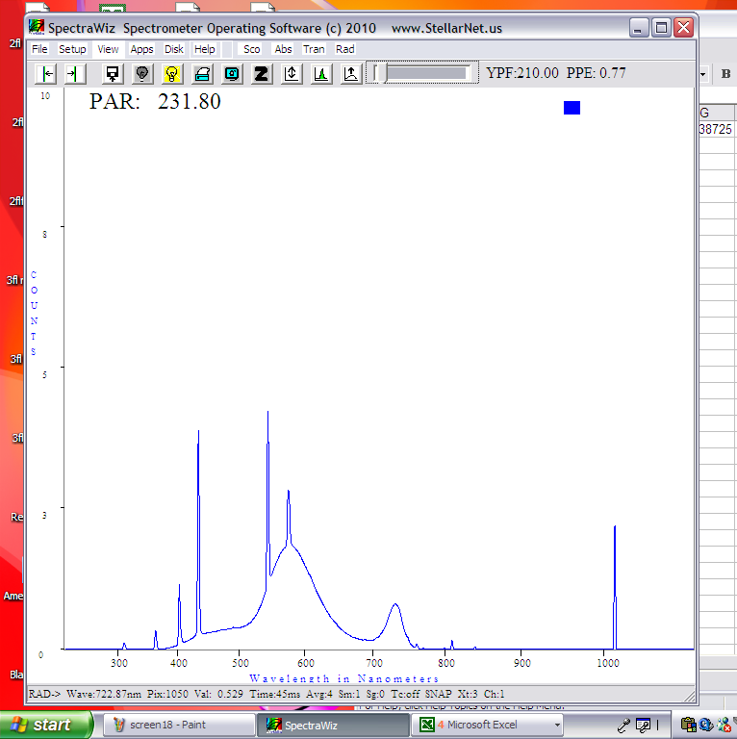

6) If you want to change ranges of PAR (default is 400 nm to 700 nm), you can go to
View > Radiometer > Setup Range for Watt and R flux measurement

You will be asked input lowest and highest wavelength (nm).
4. Store sample spectrum data (“.IRR” file)
4-1) You can save the spectrum data in a text file by File > Save > Sample.

4-2) Excel or any text editors can read the saved .IRR file. (.IRR stands for irradiance).

5. Analyze the spectrum data (eg. R/FR ratio, PAR, total fluence, draw spectrum graph) (sample R scripts are available on desktop).
<example of calculation of PAR and red/far-red light ratio, and drawing spectrum graph>
5-1) open R
5-2) open “Black_Comet_a04.R” file by “file” > “ Open script”. File location is “Desktop” in a left frame of “open script” window.
5-3) Change working directory either by (1) “File” > “ Change dir...” or (2) using “setwd” function in R (an example should be found in “Black_Comet_a04.R” script), such as “setwd(“C:/Users/Susan_Bush/Desktop/Susan”) for Susan_Bush.
5-4) select R_FR_ratio, PAR, spec.graph2 functions and run lines by “Edit” > “Runline or selection” (shortcut is CTR+R).
5-4) read your .IRR file by using read.table function. (for example Rtest.IRR in your directory, which I placed for you).
5-5) run R_FR_ratio, PAR, spec.graph2 functions. After running spec.grph2, you should have a graph like this.
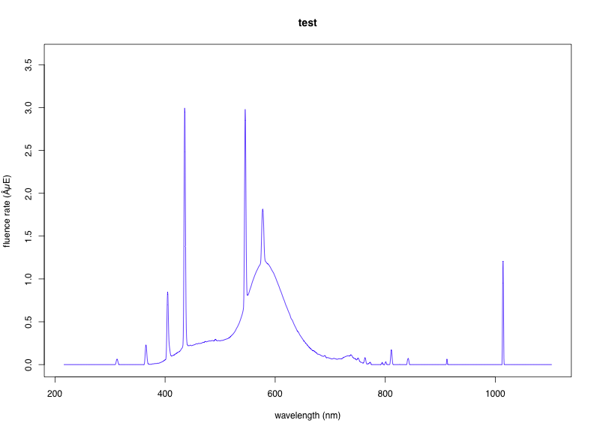

Appendix 1: Default setting:
view > Radiometer > Setup Compensation for CR2 Aperture : 100
view > Radiometer > Setup Range for Watt and Rflux measurement : 400 – 700 (for PAR)
Setup > Number of scans to average : 1

Appendix 2: sample R scripts
### calculate PAR, R/FR ratio, and graph out spectrum from Black commet data file (".IRR").
###### Kazu Nozue (Nov 08, 2011)
###### alpha version 0.4 (062112)
### R/FR function
R_FR_ratio<-function(spec,resolution){ #1st column is wavelength(nm), 2nd column is fluence rate (micro E) measured by Black Comet
#print(as.character(spec))
R<-sum(as.numeric(as.vector(spec[as.vector(spec[,1])>=655&as.vector(spec[,1])<=665,2])))* resolution;#print(paste("R=",R))
FR<-sum(as.numeric(as.vector(spec[as.vector(spec[,1])>=725&as.vector(spec[,1])<=735,2])))* resolution;#print(paste("FR=",FR))
#print(paste("R/FR=",R/FR))
return(R/FR)
}
#PAR function
PAR<-function(spec, resolution){
PAR.microE<-sum(as.numeric(as.vector(spec[as.vector(spec[,1])>=400&as.vector(spec[,1])<=700,2])))* resolution
return(PAR.microE)
}
#### plot
spec.graph2<-function(specdata,resolution, color,title) #1s column of specdata is wavelength(nm), 2nd column are fluence rate measured by Black Comet. color is "black", "red", "blue", "gree", "pink", etc
{
file.name<-gsub(" ","_",gsub(":","",Sys.time()))
pdf(file=paste("spec",file.name,".pdf",sep=""),width=11,height=8)
matplot(x=specdata[-dim(specdata)[1],1],y=specdata[-dim(specdata)[1],2],ylim=c(0,max(specdata[-dim(specdata)[1],2]*1.2)),xlim=c(min(as.numeric(as.character(specdata[-dim(specdata)[1],1]))),max(as.numeric(as.character(specdata[-dim(specdata)[1],1])))),ylab="fluence rate (µE)",xlab="wavelength (nm)", col=color, type="l",main=title)
dev.off()
}

### example
#### set working directory
setwd("C:/Users/Susan_Bush/Desktop/Susan")#
test<-read.table("Rtest.IRR",header=FALSE,skip=2) # this is Susan's data
PAR(test,0.5) # this must be 155.8013
R_FR_ratio(test,0.5) #This must be 2.258859 (middle of #13 shelf in a big chamber (501?), 050812)
spec.graph2(test,0.5,"blue","test") # find a pdf file in directory in your

Appendix 3: Troubleshoots: (under construction)

Appendix 4: Creating user account (for Kazu)
1. Inactivate “BestBuy” program from MSDOS prompt with msconfig. Uncheck “BestBuy” in startup tap and apply and click “OK”.
2. Inactivate internet. control panel > network and click network name and disconnect it.
2. Copy data folder on Desktop or make data folder.
3. Add Rtest.IRR file in the data folder.
4. Copy sample R script to Desktop.
5. Copy “Shortcut to SpectraWiz”, R, and Micro Office starter > excel and word to Task bar.
6. Restart computer.

