96 Well Plant Genomic DNA Microprep

May 12, 1994, updated 8/23/96
Modified from Edwards et al., 1991 NAR 19: 1349. Via The Gasser Lab

1. Harvest tissue into the 8 well cluster tubes, or 2 mL eppendorf containing ~3 beads and 400 µL of extraction buffer (200 mM Tris•Cl pH 7.5, 250 mM NaCl, 25 mM EDTA,).
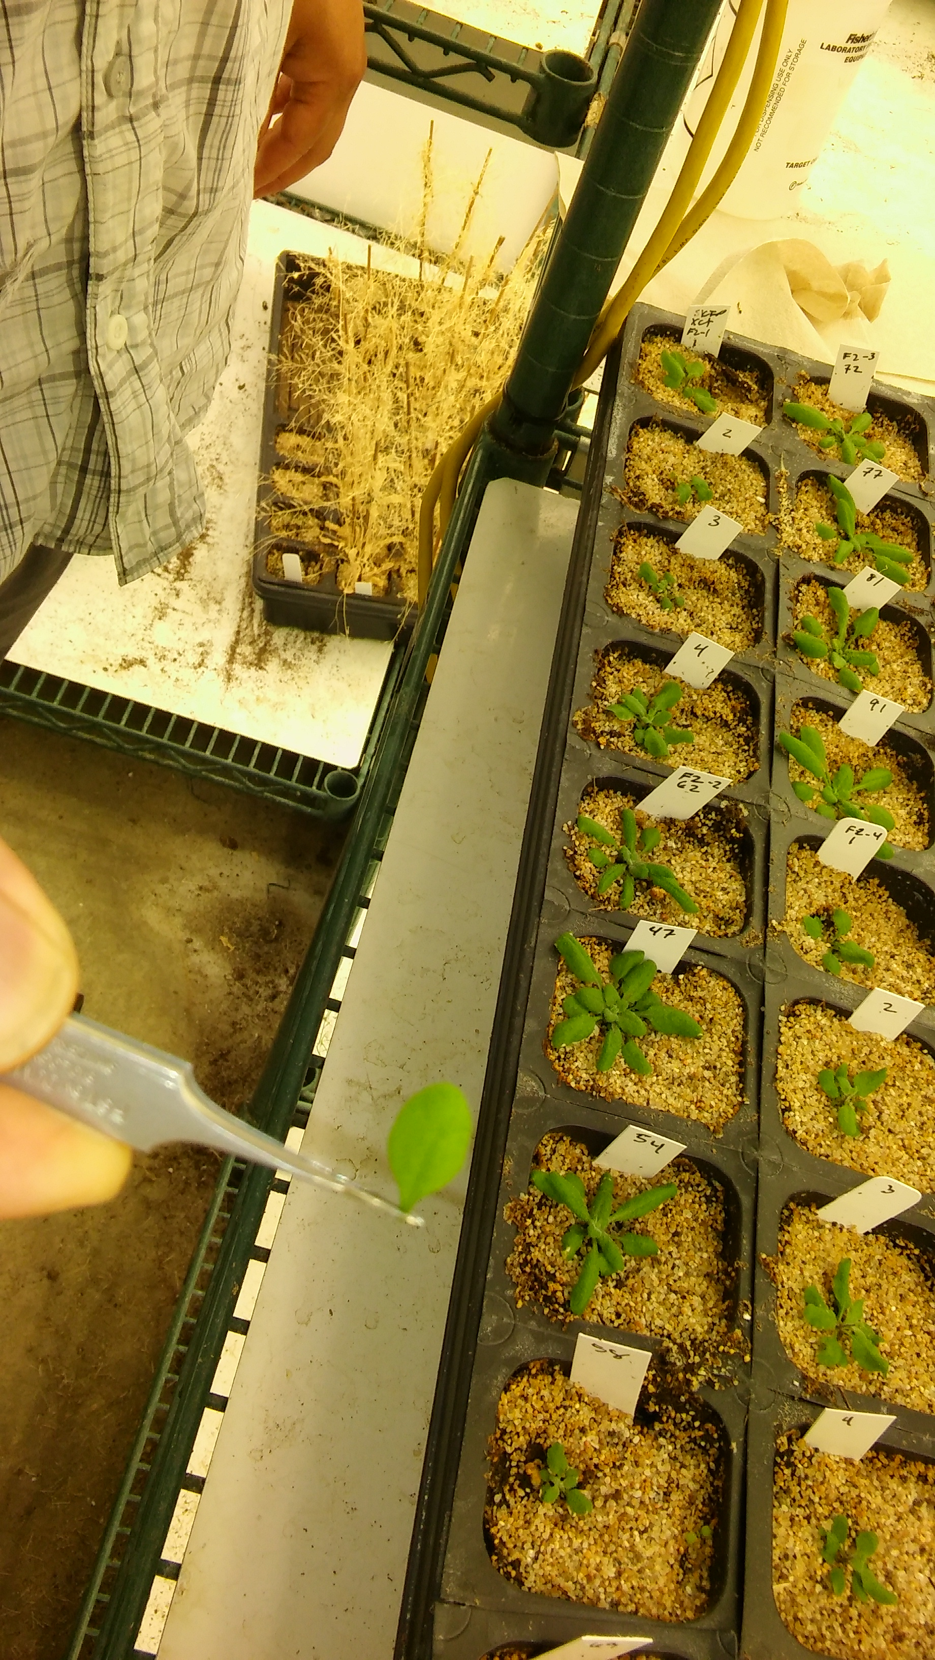
- Place plate/tubes in beadmill for 2 min. Check if samples are homogenized. Beat for additional time if necessary.

- Add 20uL of 10% SDS to each well. Shake gently by hand.

- Spin in table top sorvall 3000rpm 10-15 min (depends on the amount of extra material in the tube). For eppendorf tubes use microfuge at full speed for 10-15min. CAUTION: do not spin plates faster than this because they will crack.

5. Transfer 200 µL of supernatant to the new 96 well plate/1.5 ml tube containing 200ul of 2-propanol. Try to avoid plant tissue. . Invert tubes to mix!

6. Leave at Room Temperature for 2 min
-Spin in table top sorvall 3000 for 30 min or microfuge at full speed.. CAUTION: do not spin plates faster than this because they will crack.

7. Decant supernatant. If using plate protocol, invert the plate over the sink and blot dry on a paper towel. Note: Tape the tubes to the box, they will be inverted without caps so they need to stay in the box.
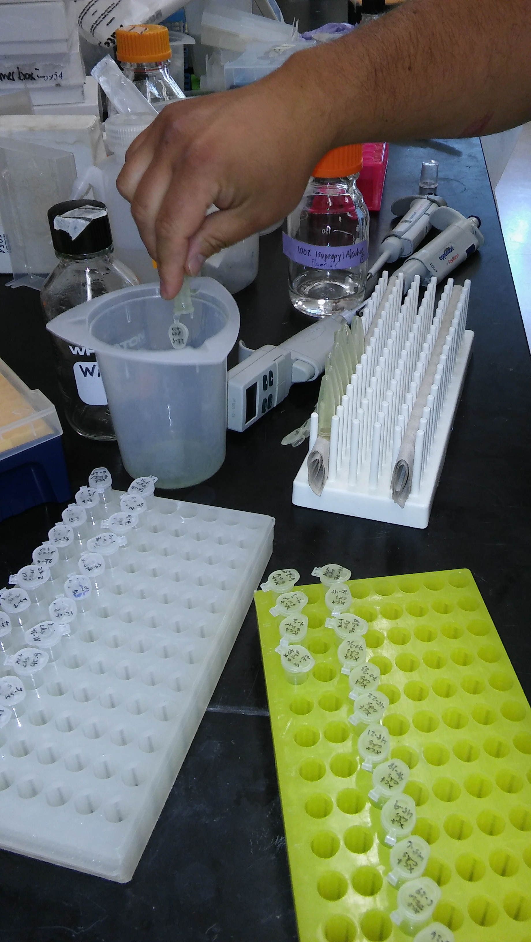

8. Rinse 200uL 70% ethanol. Shake tubes to mix, centrifuge at 3000rpm/full speed for eppendorf tube for 5min. This helps re-condense the pellet.
- Drain EtOH and dry by leaving rack upside down on a paper towel with one end propped up until the EtOH dries (doesn’t smell strongly anymore, 15min). Watch that pellet doesn’t begin to slide out.

9. Resuspend pellets in 50-100 µL of 0.1mM TE or water.
-Shake to re-suspend pellet then spin to clear solution. Store samples at -20C.

Notes
6. The prep will still work if a small amount of plant tissue is accidentally carried over at this step.

Use 2uL of DNA for PCR

100mL Extraction Buffer

5 mL 5M NaCl
20 mL 1M Tris pH 7.5
5 mL 0.5M EDTA pH 8
70 mL H2O

